1. **Compared with indexed allocation**, list at least one advantage and one disadvantage of chained allocation.

Advantage: Reduced External Fragmentation.   
Disadvantage: Slower Read/Write from large files.

1. **Free Space Table** (FST) is used to manage unallocated blocks. Does FST uses up space that might have been available for files? Explain why. Provide an outline of a solution that will not have this issue.

The FST should not take up space that files would use. The FST can be moved if it is occupying a critical block.   
  
Solution: The block containing the FST is marked as “Free”. If a file needs the block containing the FST, then it should be moved.

1. Programs are often linked to be loaded at the same or overlapping memory addresses. What problem(s) it creates? Outline short a solution.  
   This could cause filled memory to be overwritten, which would cause necessary data to be lost.  
     
   Solution: When you need to allocate memory, scan to find the next unallocated space. Deallocate memory once you are done.
2. Explain what are **physical address**, **logical address and relative address**?  
   The physical address refers to the static address in memory. The logical address refers to the address generated by the CPU. The relative address refers to using an “offset” from a base address.
3. Using the Figure below, talk about the three placement strategies (First-fit, Best-fit, Next-fit). What are their respective advantages and drawbacks?   
   First-fit: The program scans for the first free block of memory that is large enough.   
   Advantages: Faster than best-fit. Simplicity, easy to implement.   
   Disadvantage: Concentrates free space at the end, which lowers performance.  
     
   Best-fit: The program scans for the smallest free block of memory that is larger than the required space.  
   Advantages: Utilizes space efficiently.  
   Drawbacks: Low performance because a full scan is required for every new allocation. Creates very small sections of free space that cannot fit anything.  
     
   Next-fit: The program scans for the first free block of memory after the previously used block.  
   Advantages: As fast as first-fit. Does not concentrate free space.  
   Drawbacks: More complex than first-fit.

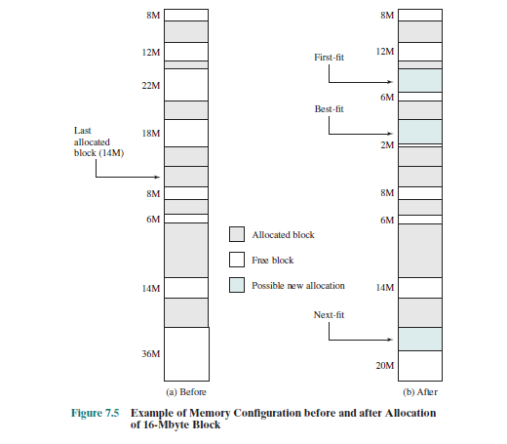

1. Consider situation when there is enough free memory to accommodate a single process, but no single free memory area is big enough for it. What can be done to load this process in the memory? What are drawback(s) of this solution?  
   Defragmentation can occur, which reorganizes the memory to concentrate free space. The drawback of this process is slow performance.